**SCREEN SHOTS OF LAB SESSION DATED : 30/12/2021**

FIRST SCREEN AS AN ADMIN

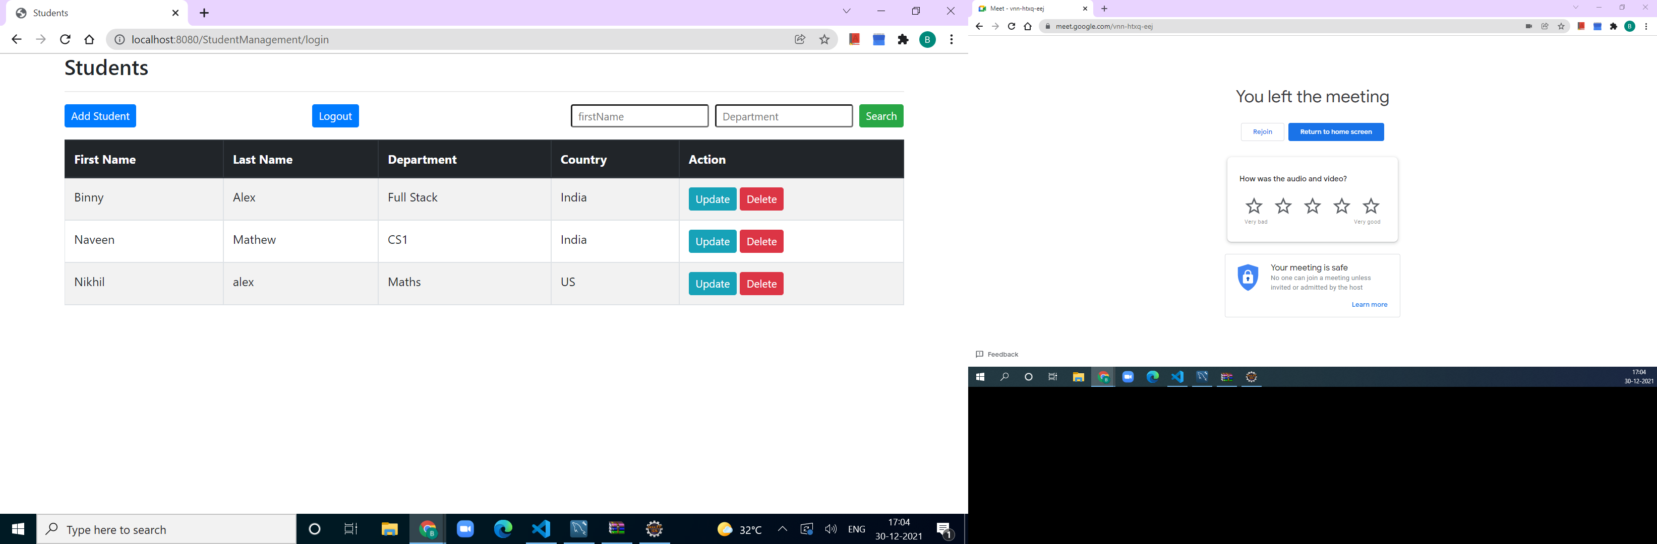

ADD A STUDENT

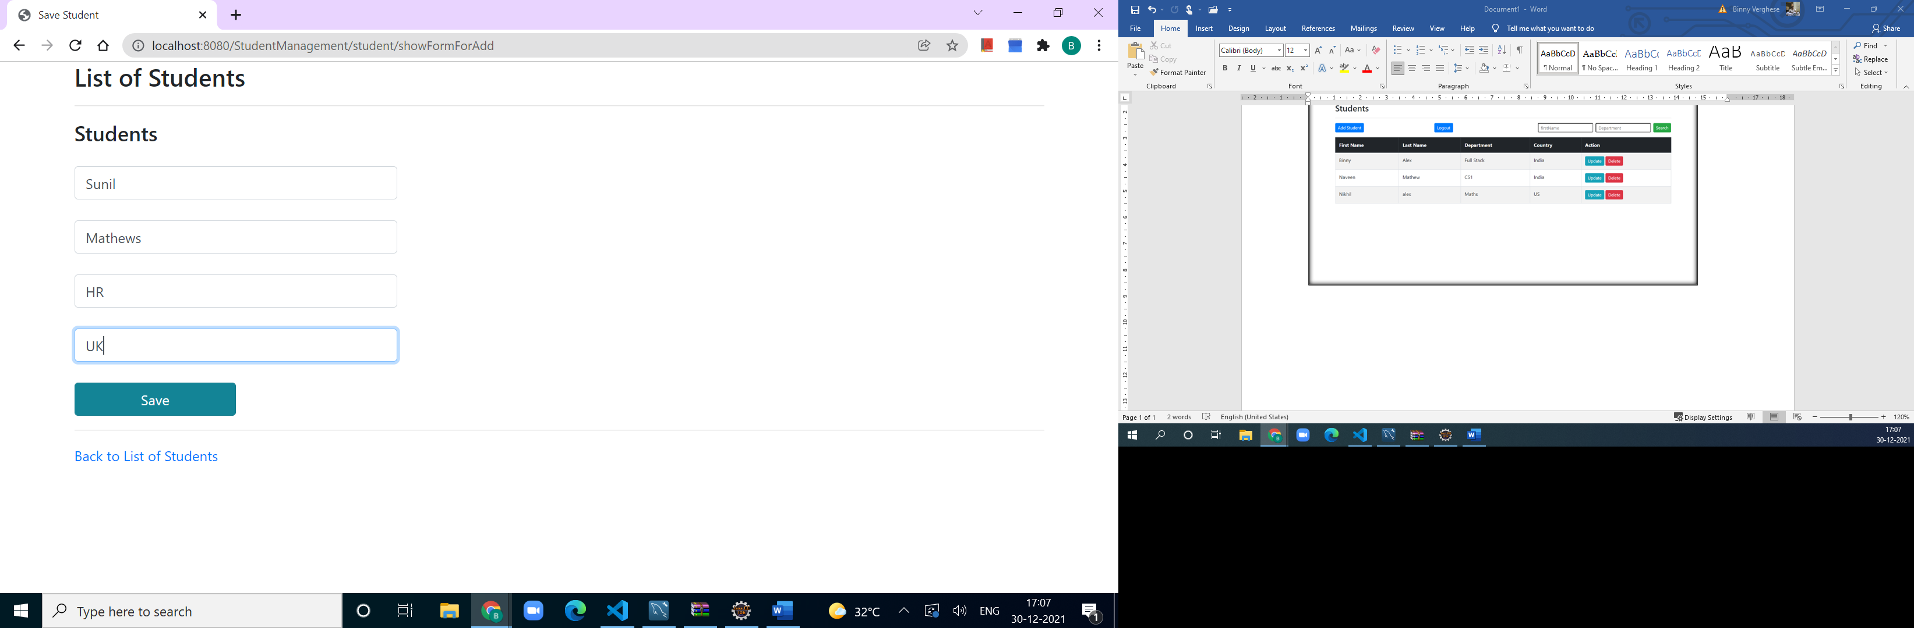

LIST OF STUDENTS

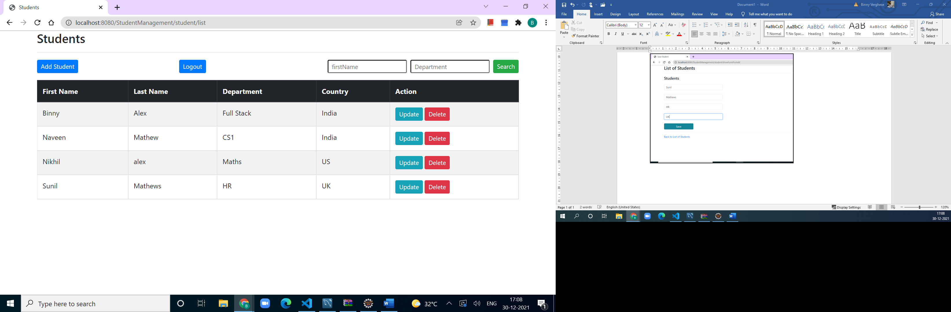

UPDATE DETAILS OF NIKHIL

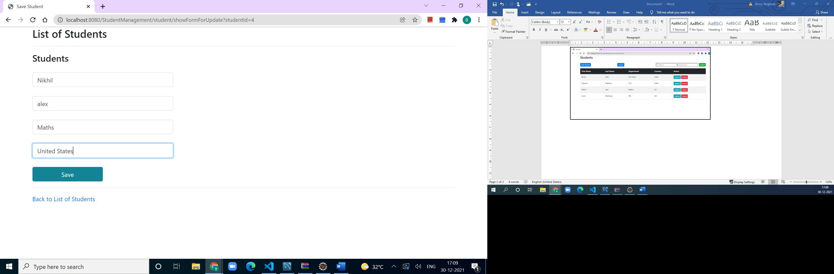

REFLECTION OF CHANGES

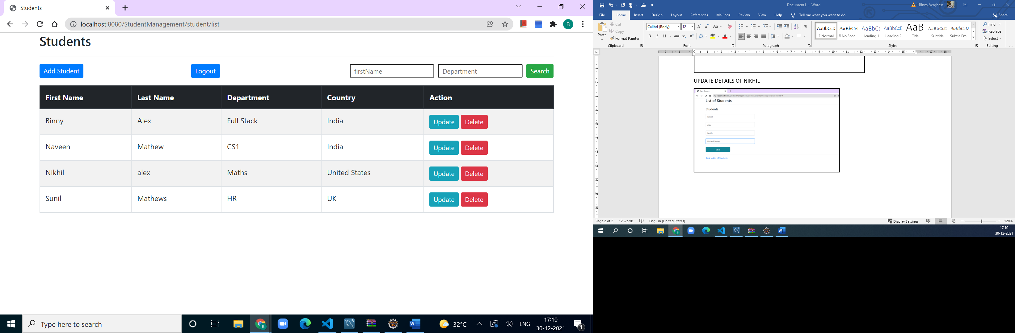

DELETING SUNIL’S RECORD

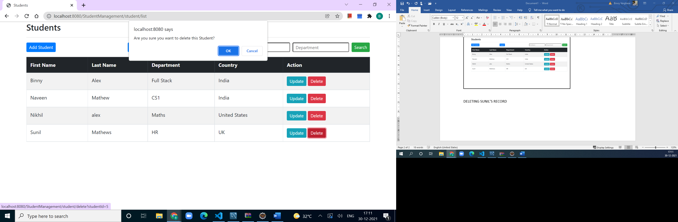

Search a record

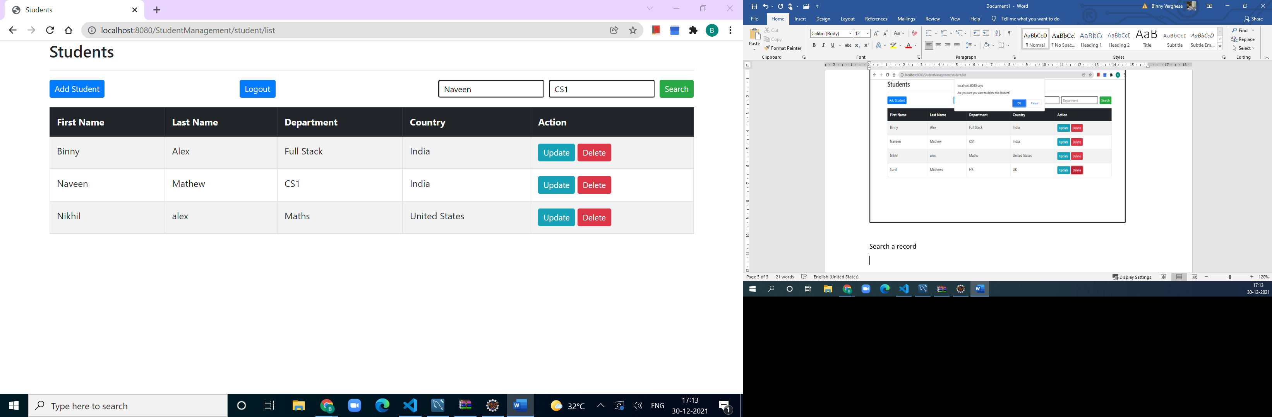

IDENTIFYING AND DISPLAYING

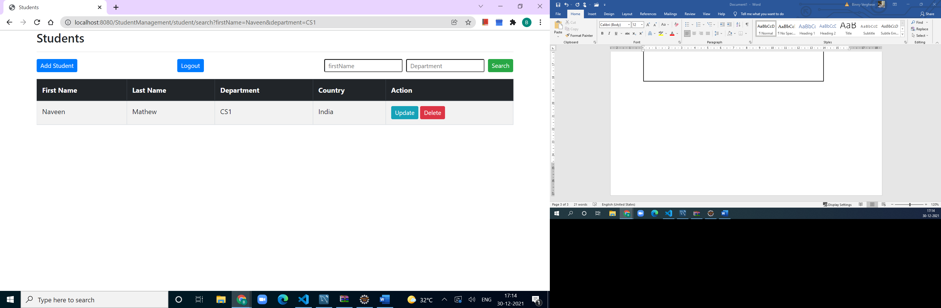

As an USER, no right to delete

